PROJECT – 2

Deploy wordpress application with

amazon web services

* What is Word-press.
* .At its core, **WordPress is the simplest, most popular way to create your own website or blog.**In fact, WordPress powers [over 43.3%](https://kinsta.com/wordpress-market-share/) of all the websites on the Internet. Yes – more than one in four websites that you visit are likely powered by WordPress.

1. Go to console log into root user.

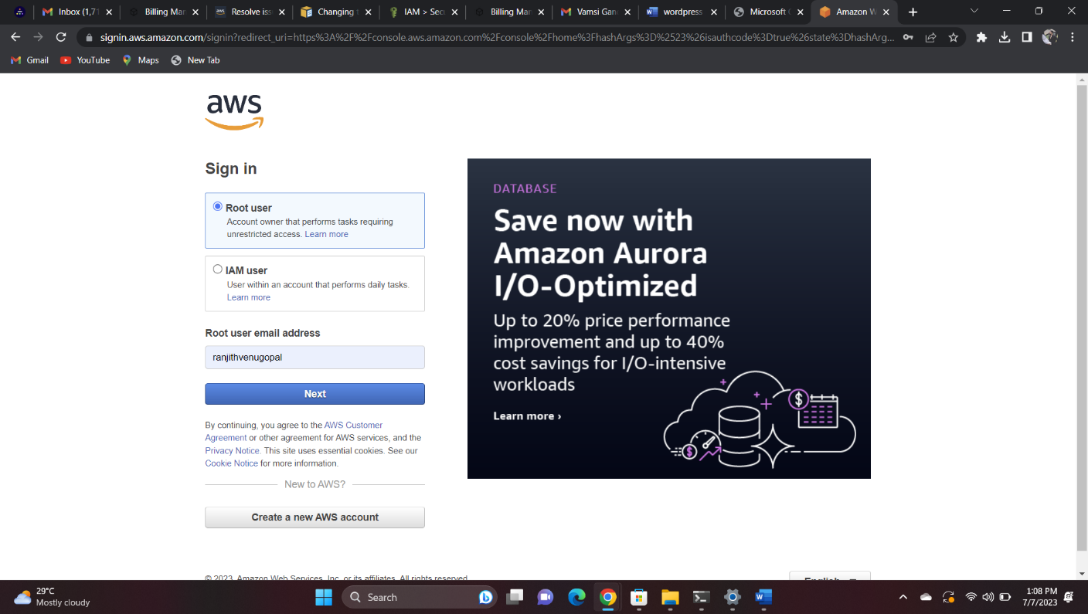

2.Create IAM user log into IAM user.

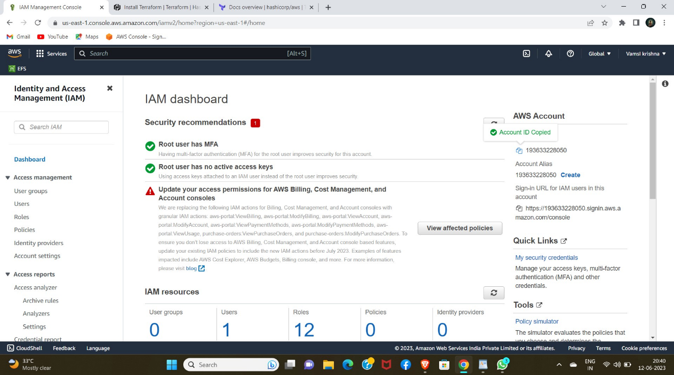

3.Create a VPC in CIDR "10.0.0.0/20"

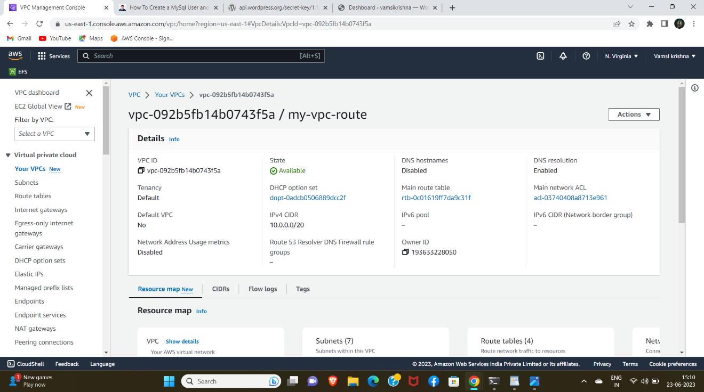

4. Create Private Subnet and Public Subnet with different availability zones.

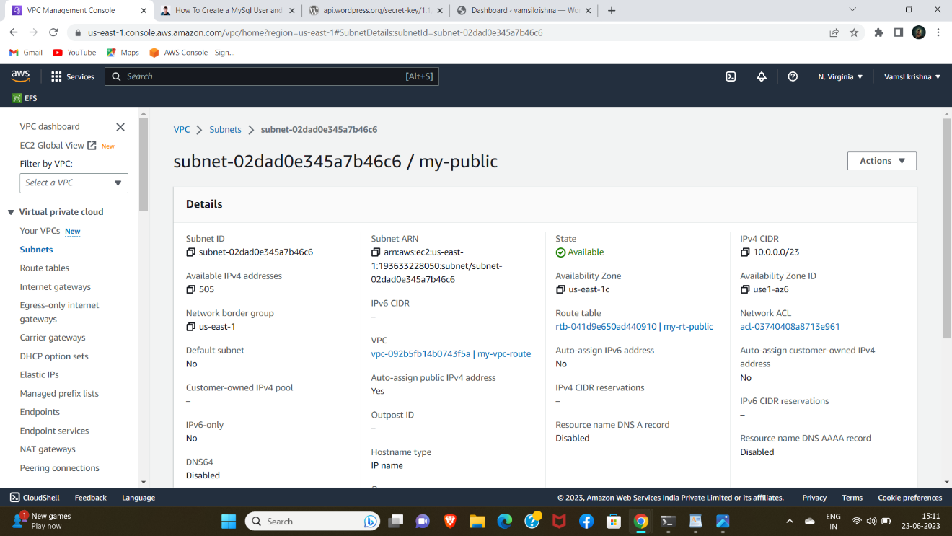

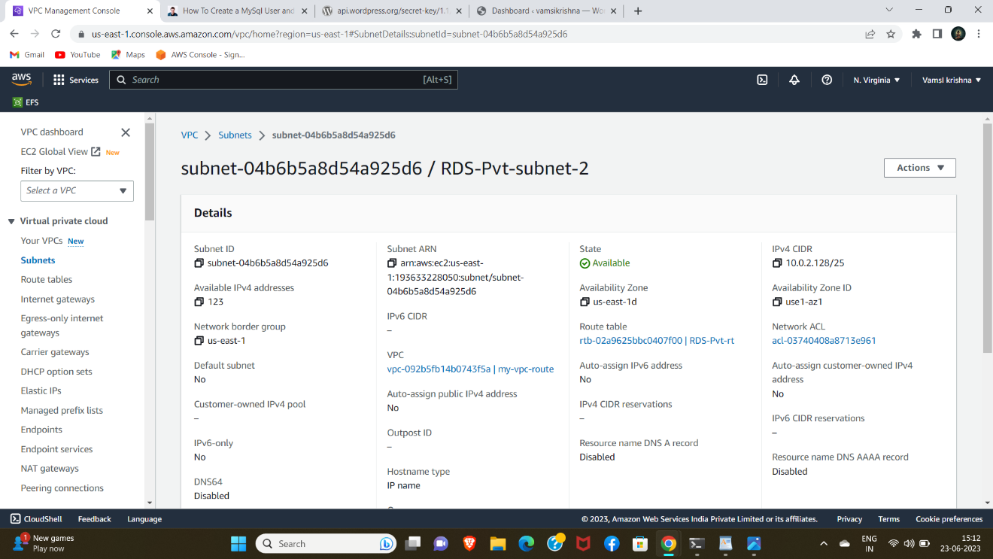

5. Create Internet Gateway for VPC and associate with Public Subnet.

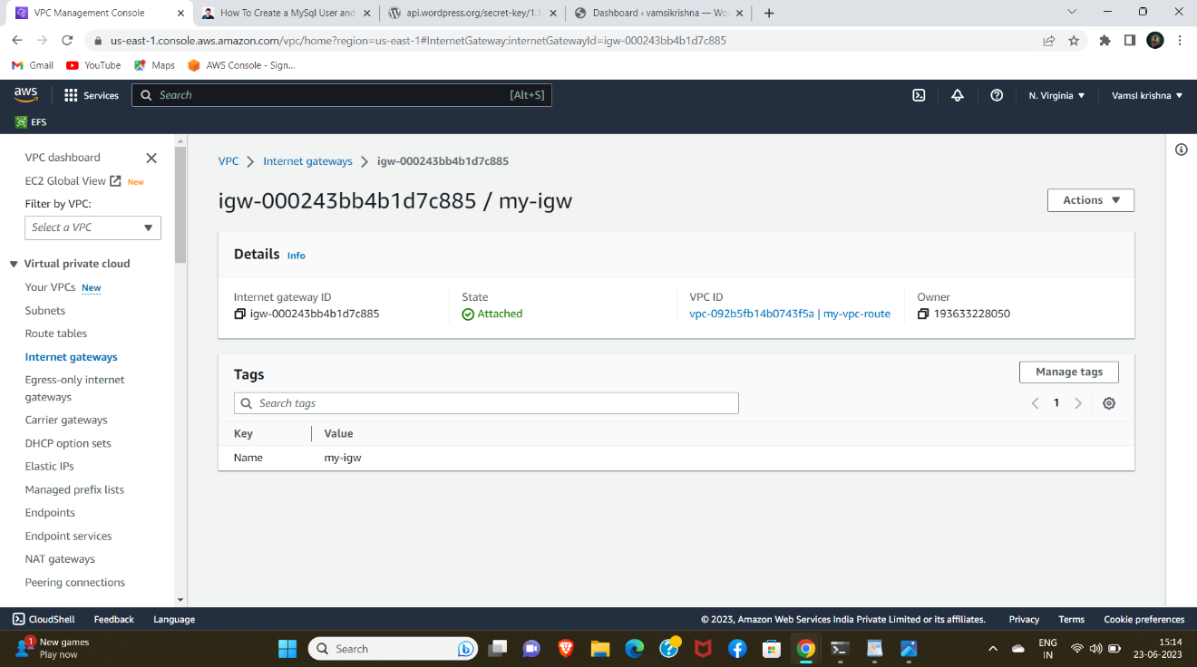

Create NAT gateway using public instance associate with private instance.

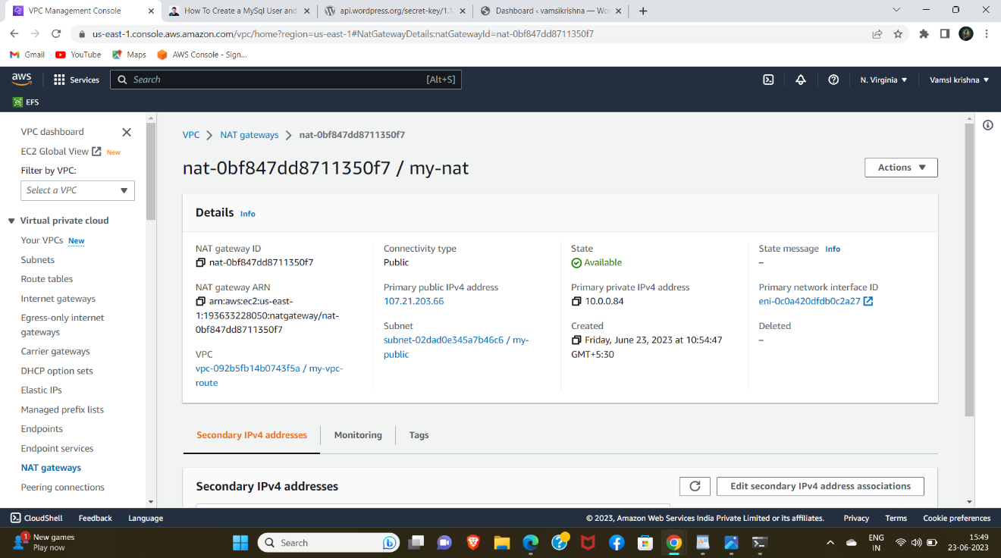

9

6.Create Public route-table and Private

route table for VPC.

1.In Public rt attach Internet gateway and public subnet.

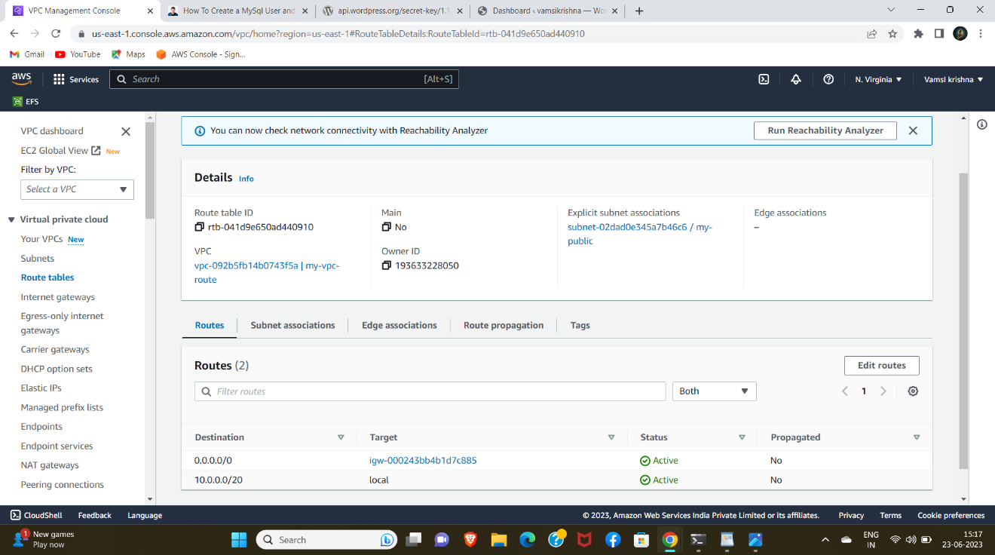

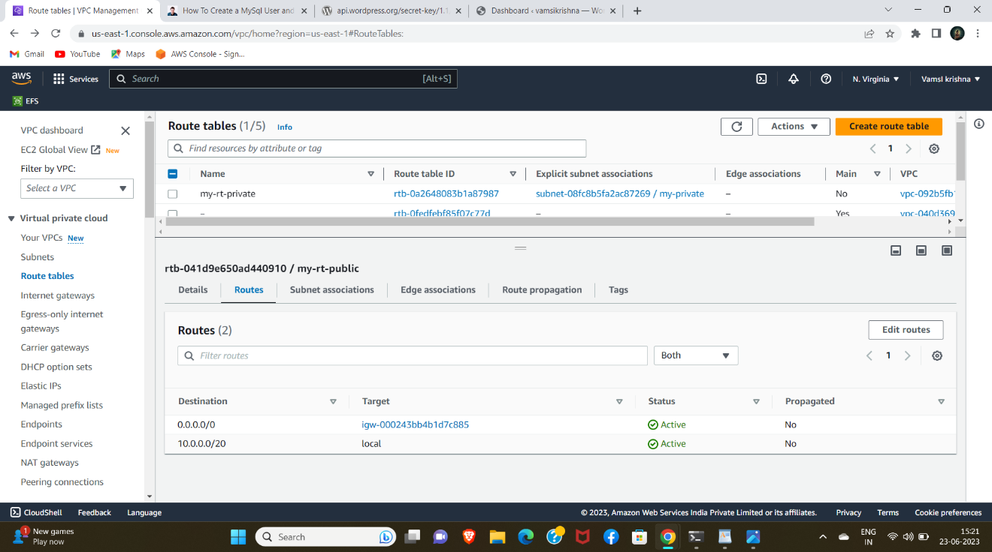

2. In private rt attach private subnet and NAT gateway.

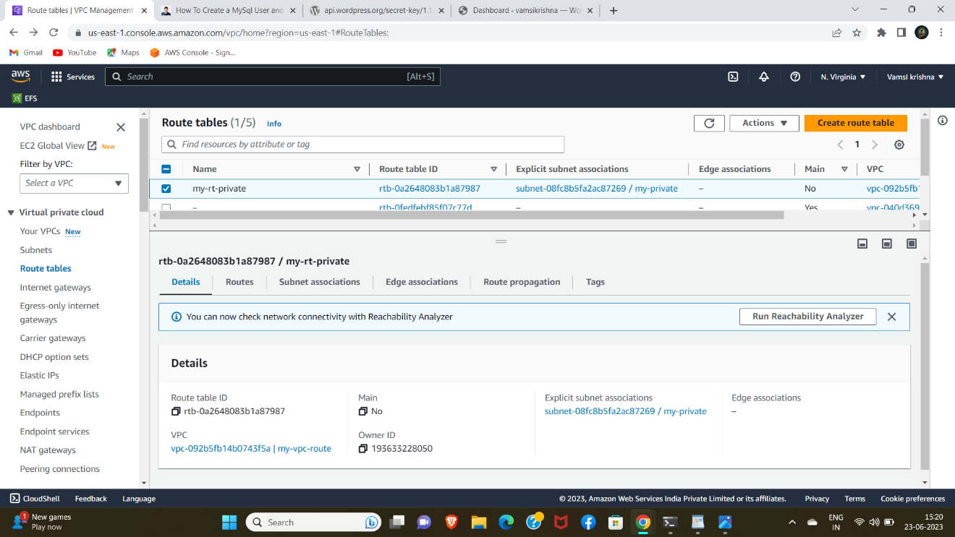

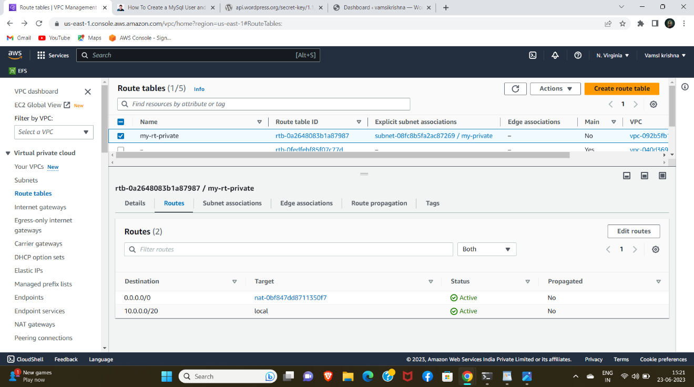

7.Create public instance attach VPC and SG give port 80.

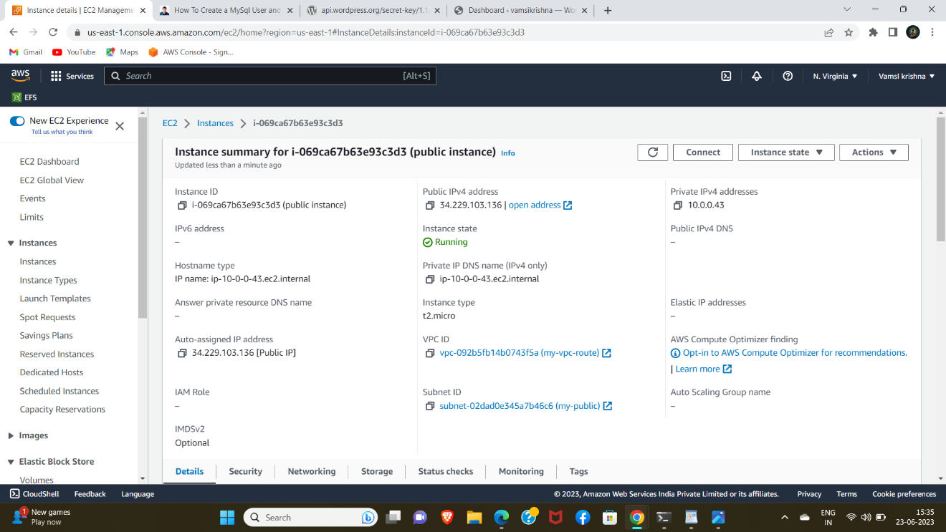

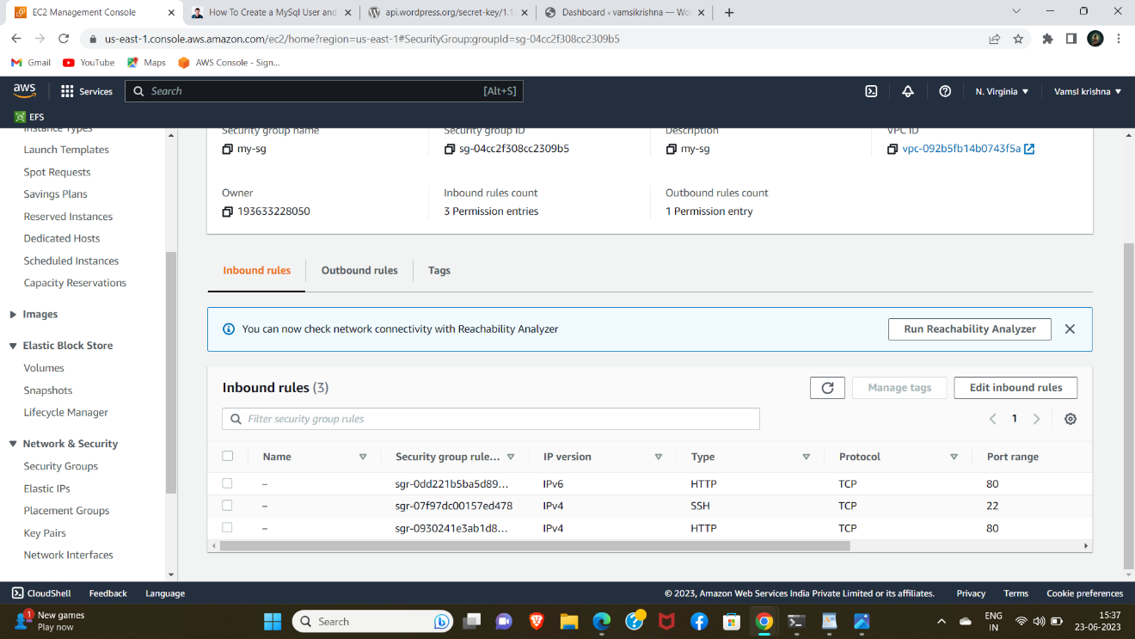

8. Create a Ec2 instance in VPC and Sg assign port 80 & 3306

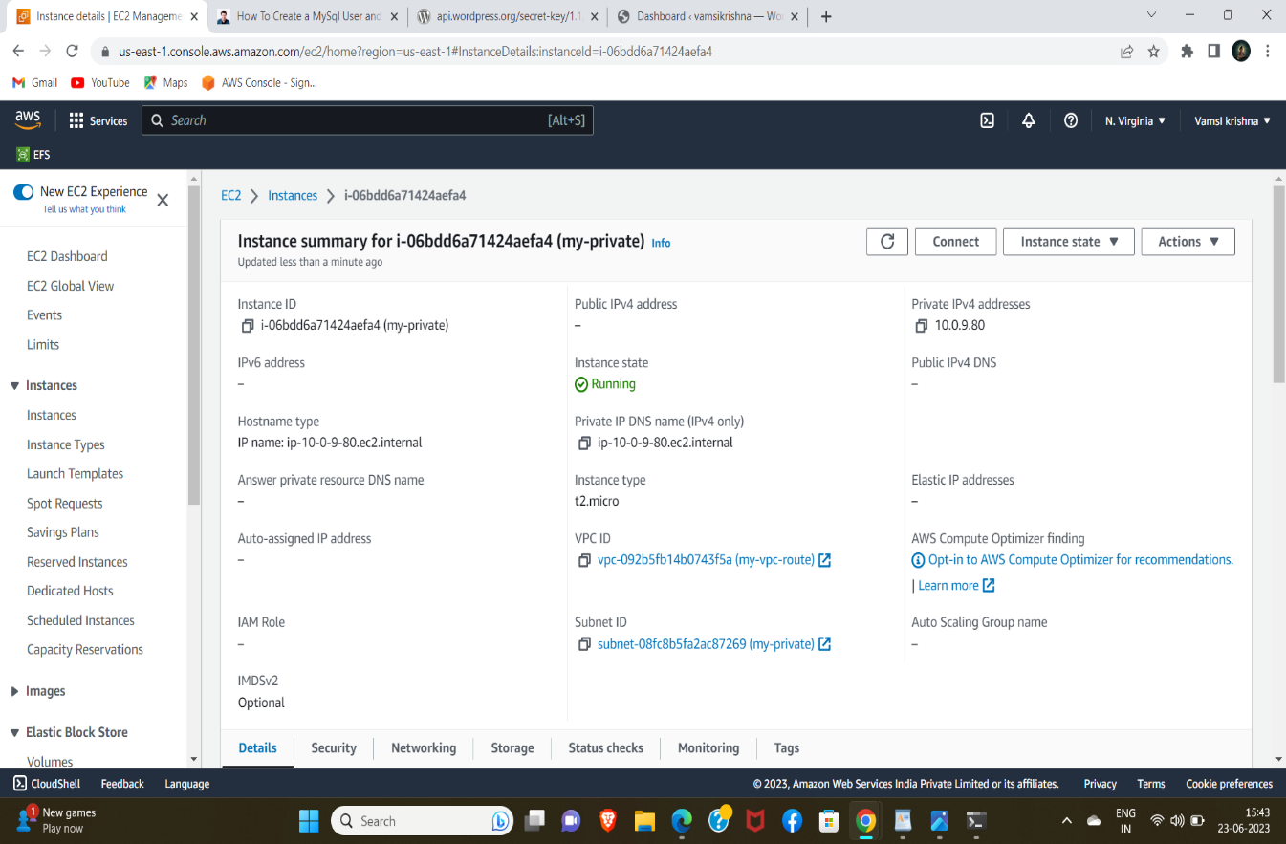

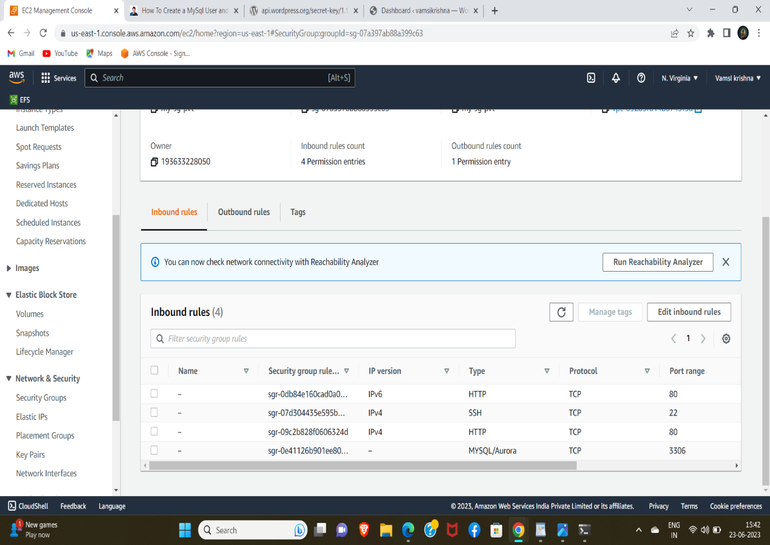

9.create RDS database using mysql and create default subnet group ..

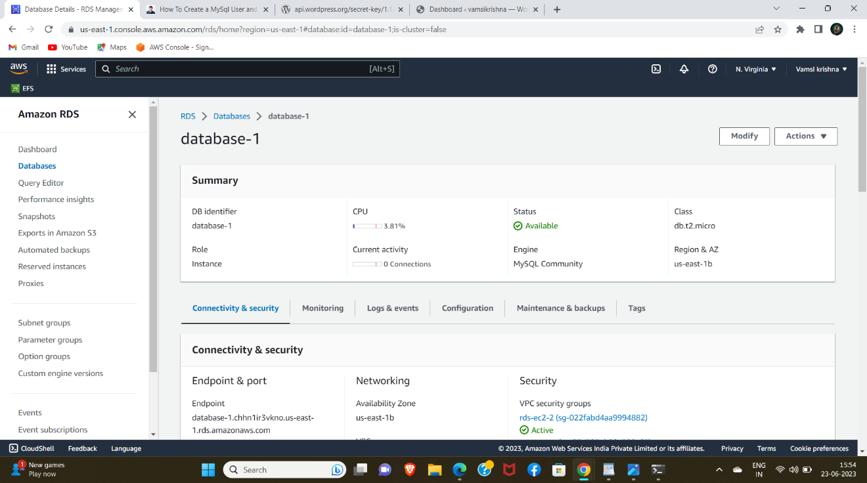

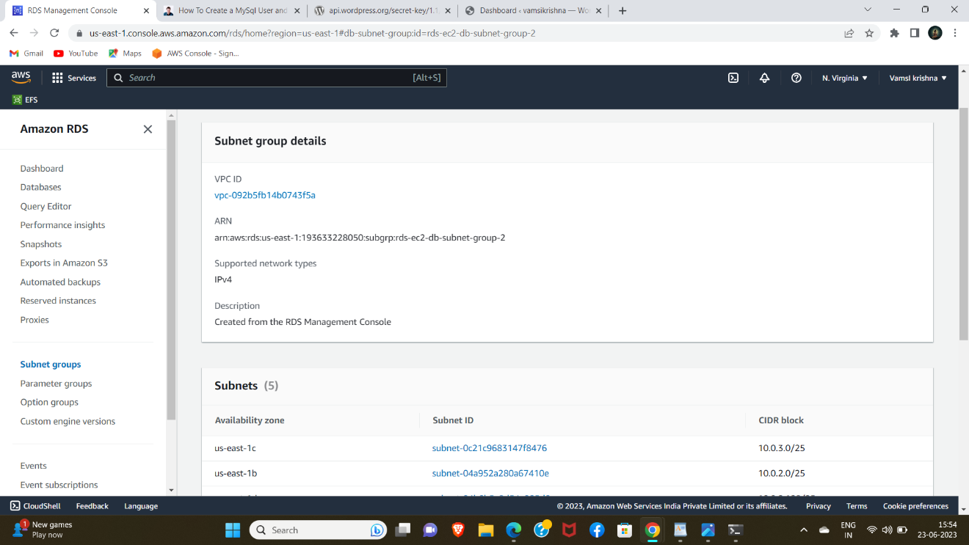

10.Connect public instance in terminal.

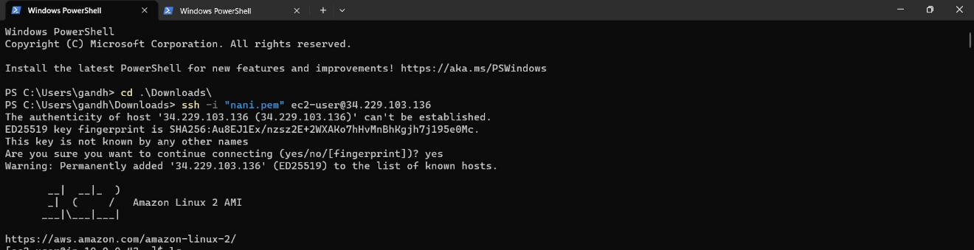

11. open new window and copy pem file using command (scp -i pem.pem ec2-user@public ip :~)

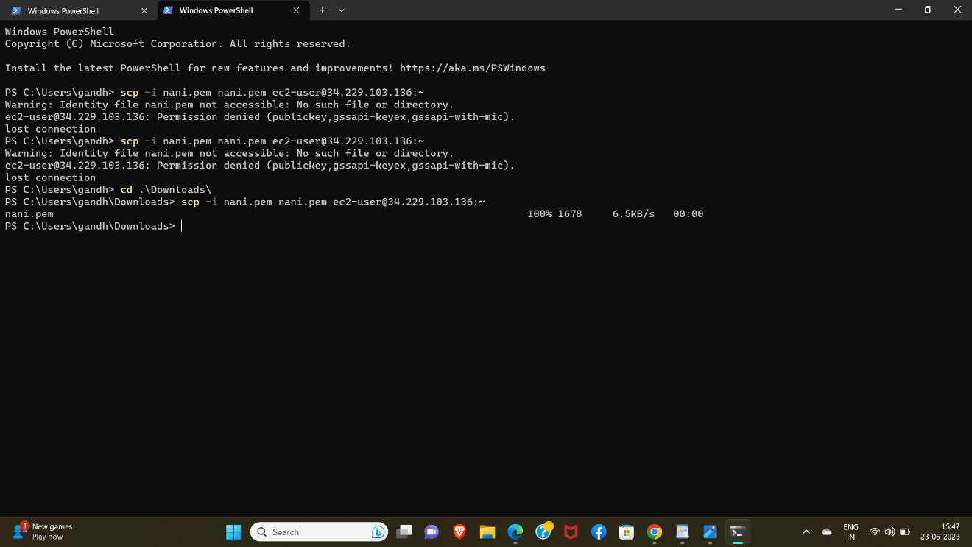

12.check for public instance and change root module.

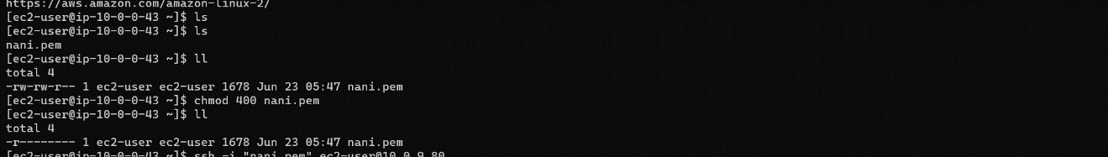

13. Install word-press for our local machine.

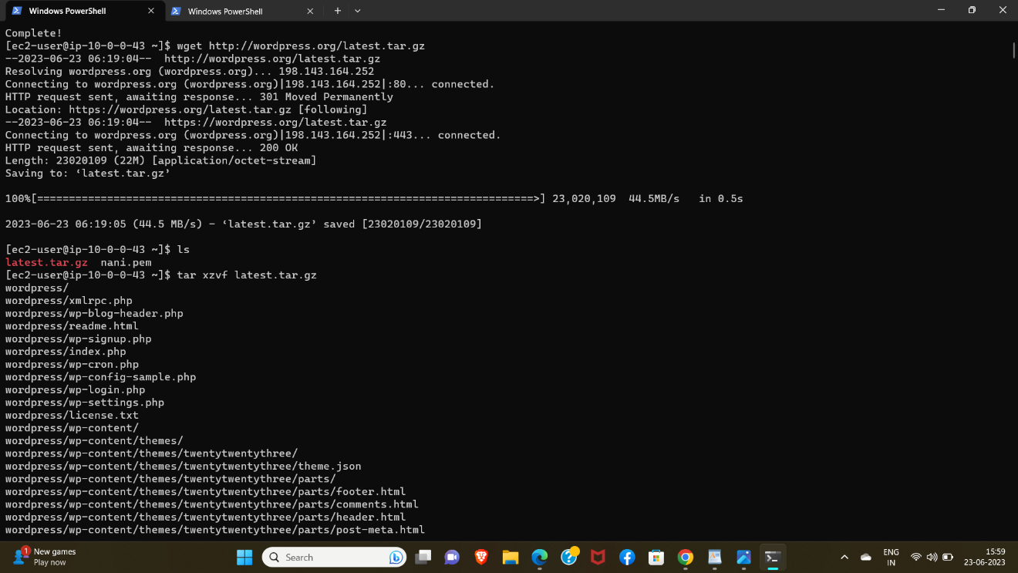

14.goto word-press directory and give ls to see files.

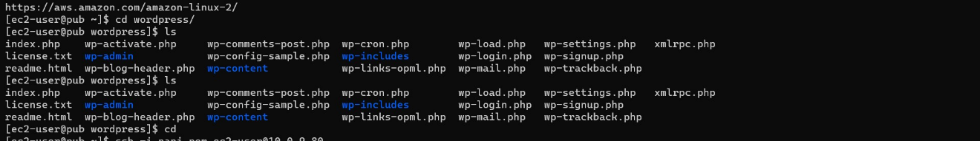

15.Install mariodb, php, mysql. (To search for commands, install php mariodb in amazon linux)

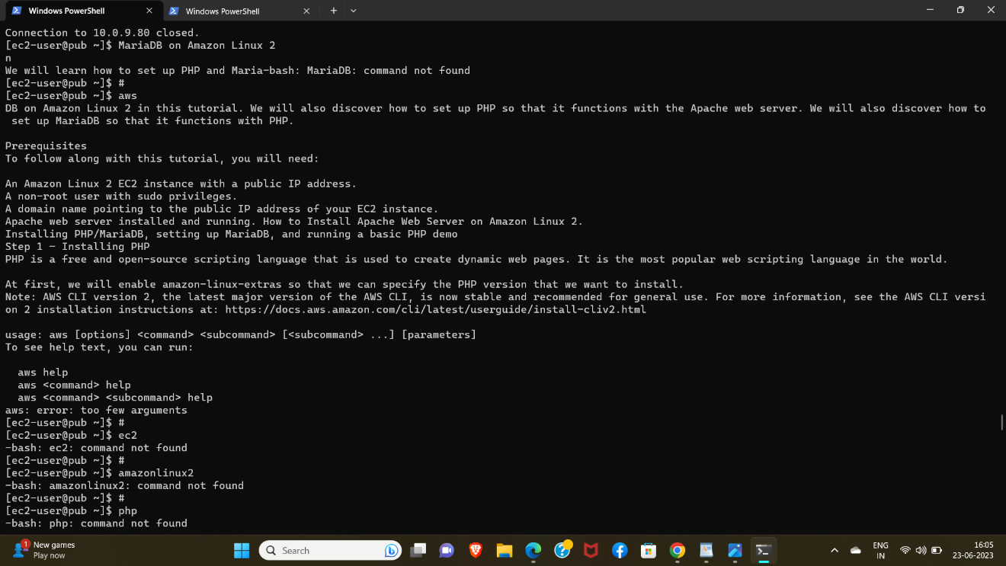

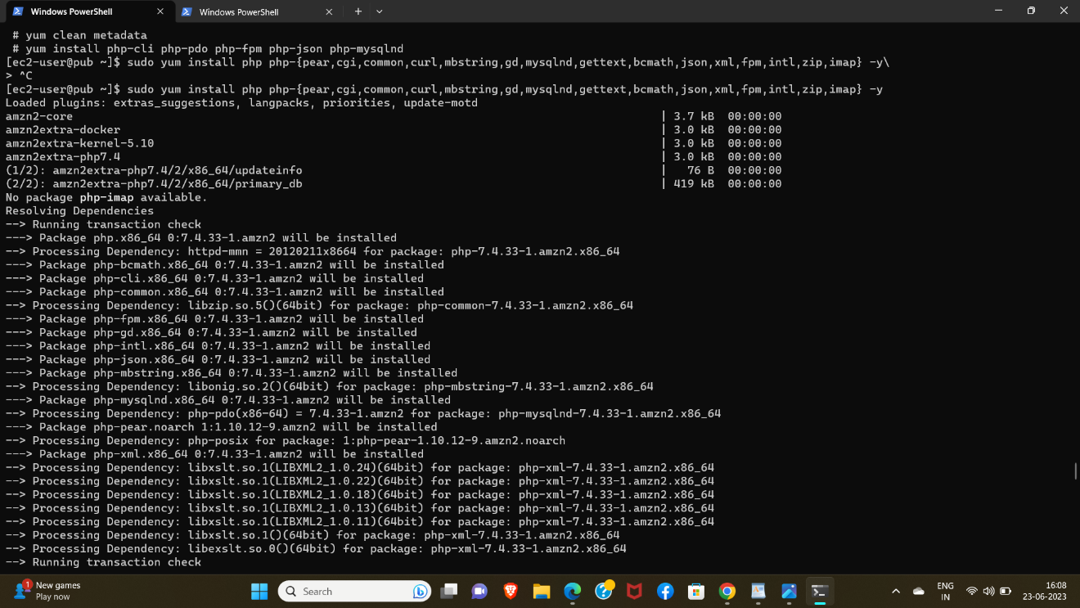

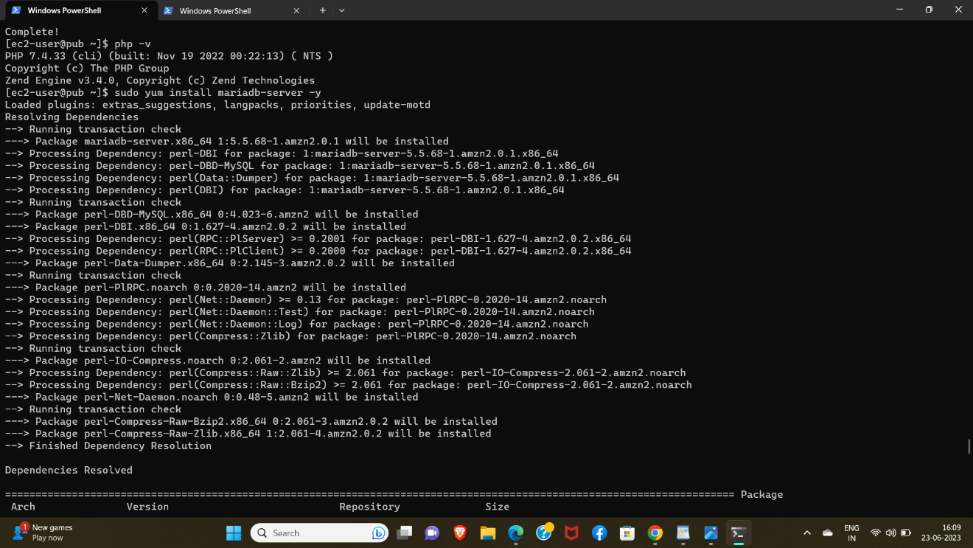

16. After installation start and enable mariodb and generate a new password.

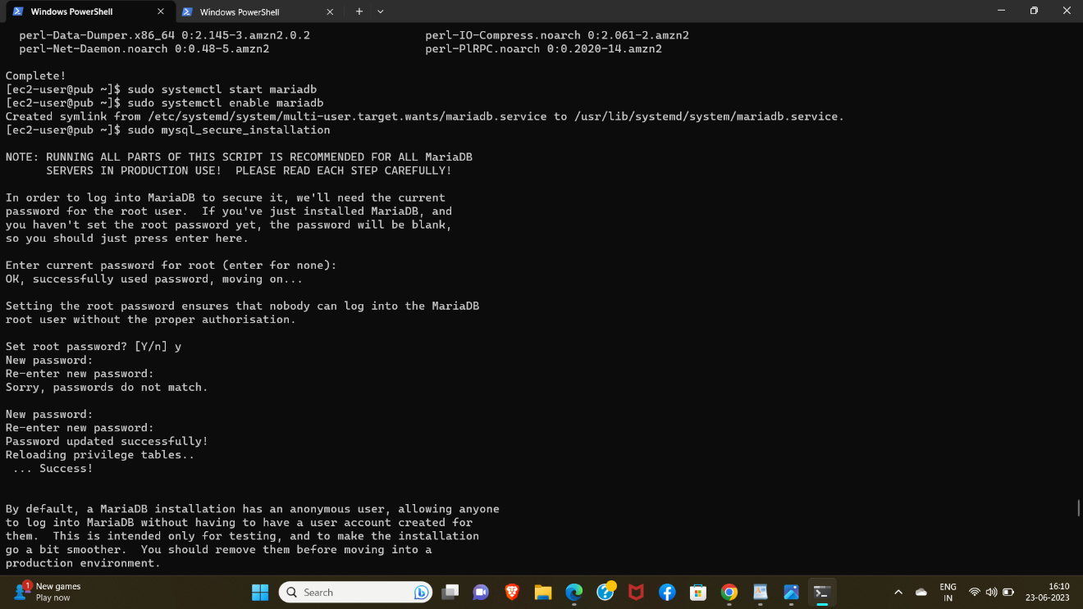

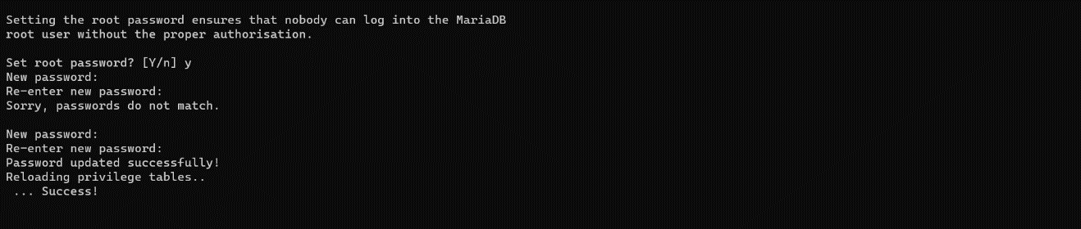

17. After installing mariodb connect public through private instance using command (ssh -i pem.pem ec2-user@private ip)  
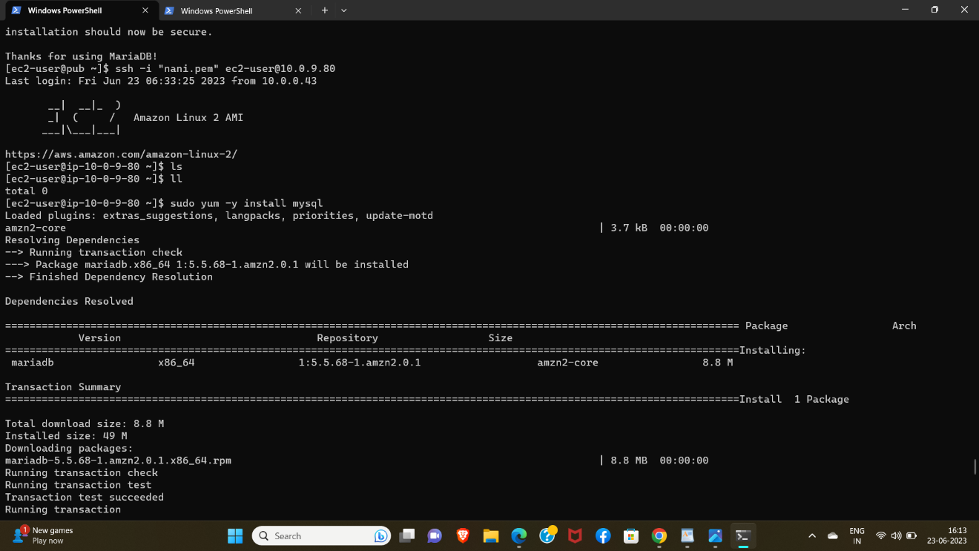

18.Connect into mysql and create rds. user for mysql and exit.

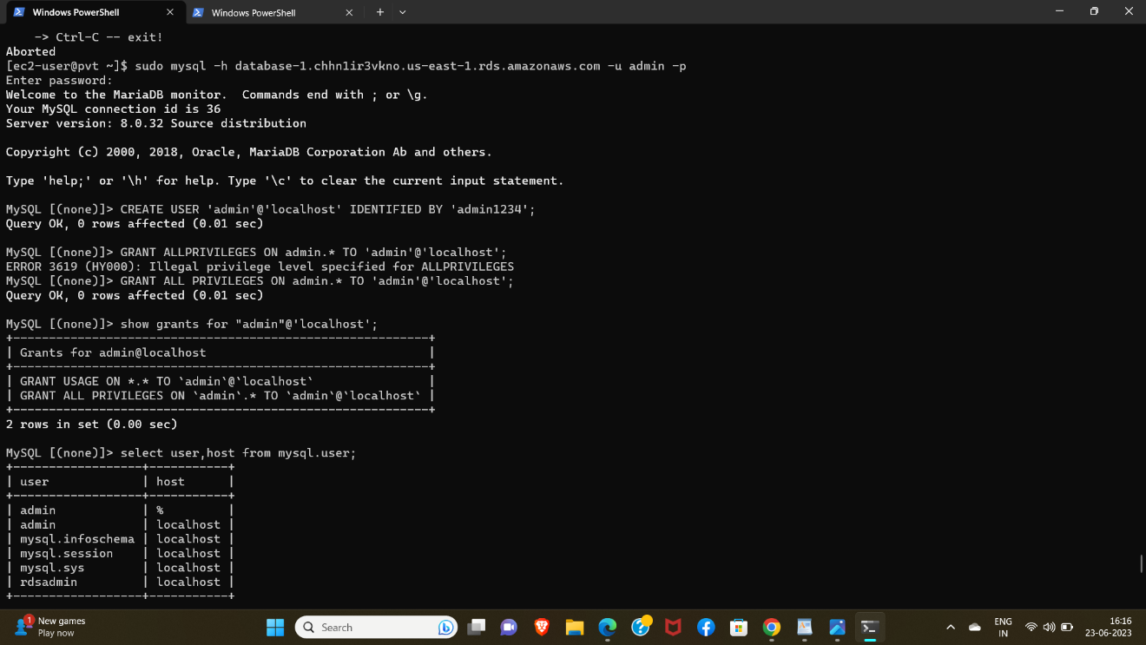

19.After we exit from private instance, we are in public instance then we have to go into WordPress and "create vi file for wp-config.php "and give "ls" to see files and "copy files from wp-config-simple.php to wp-config.php".

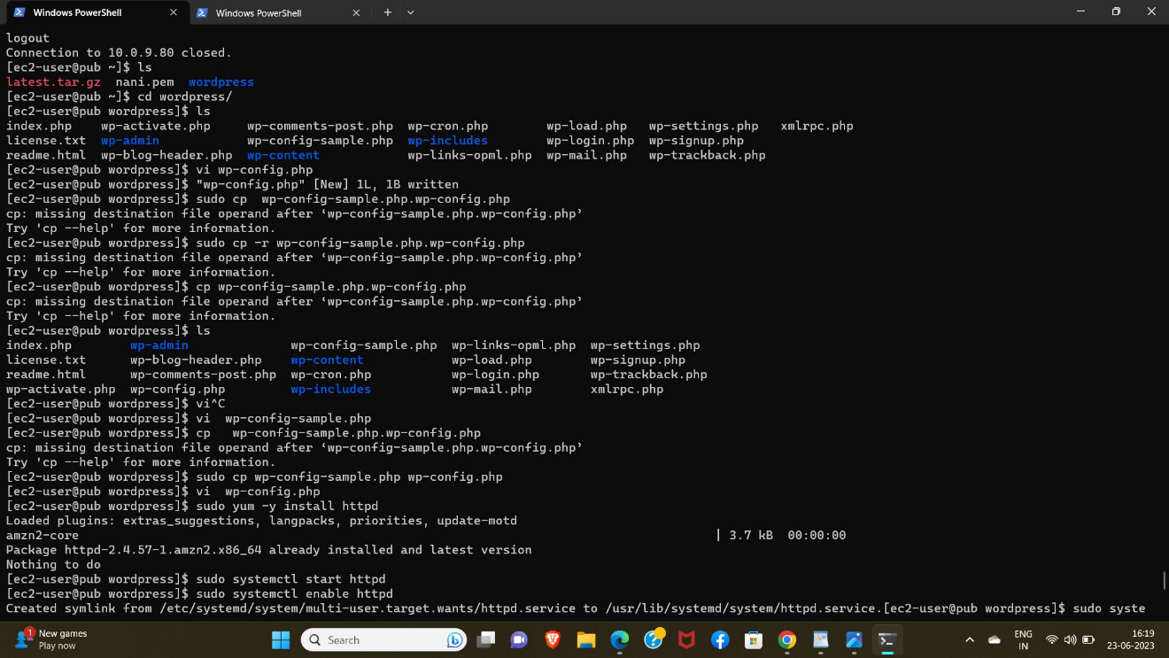

20.Open config file like " vi wp-config.php" and modify keys and username and password and database end point in host. and save.

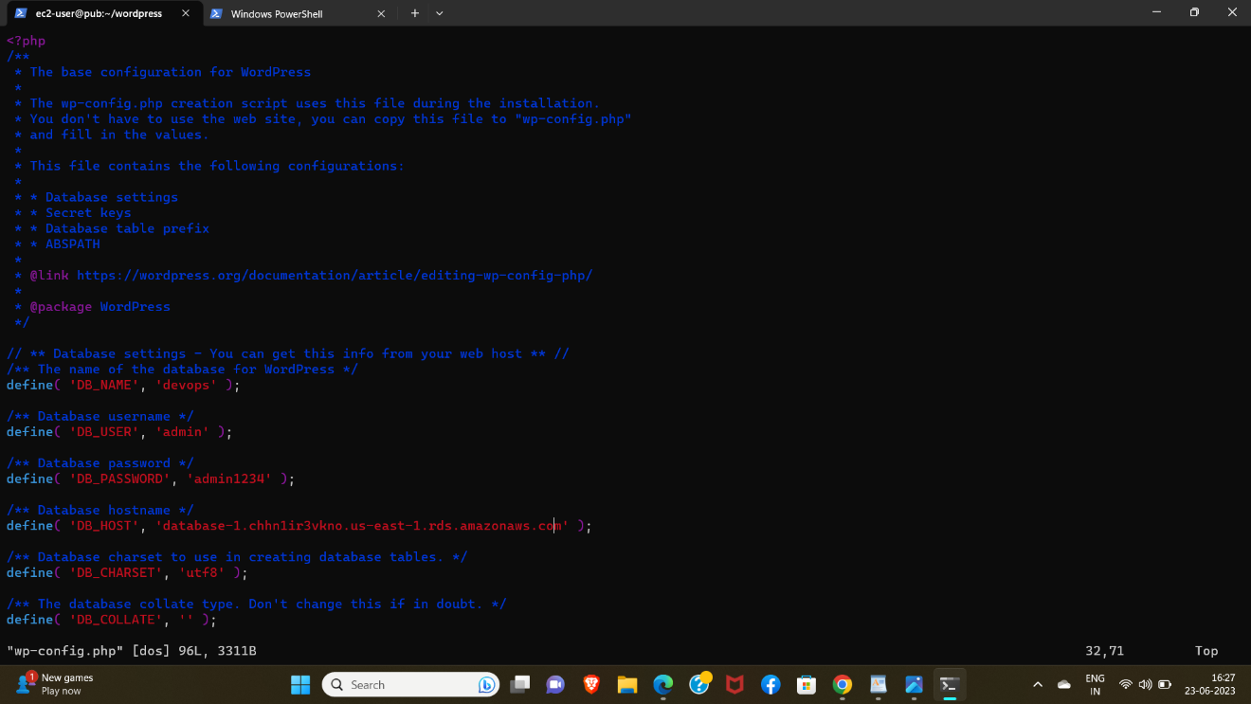

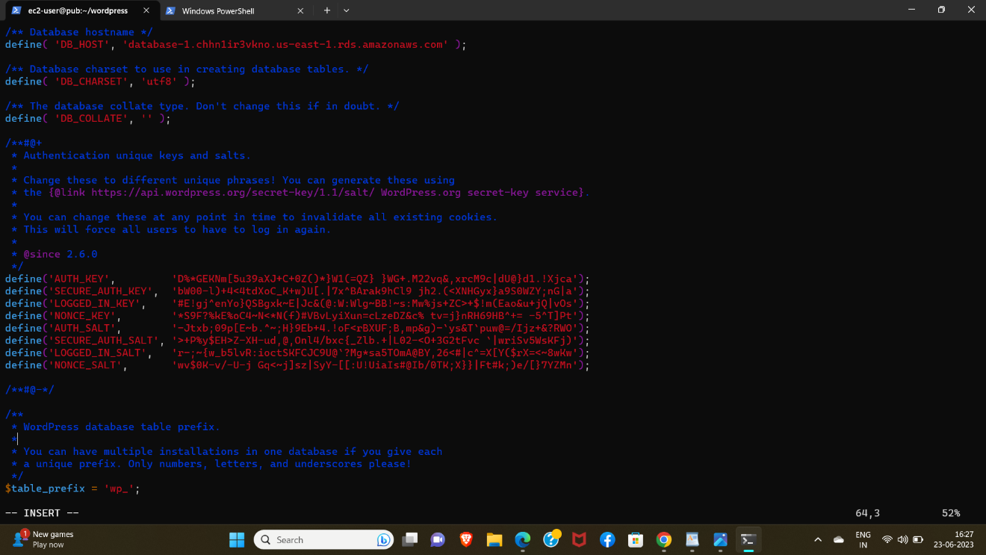

21.Install and start and enable httpd

and restart also.

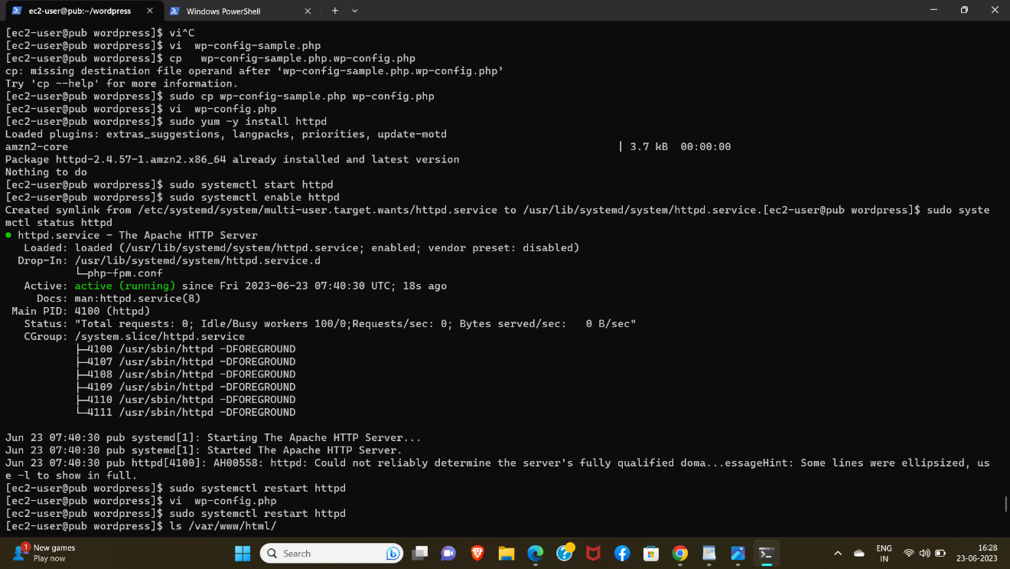

22. Then browse public instance public ip address and assign port ":80" then show the wordpress page.

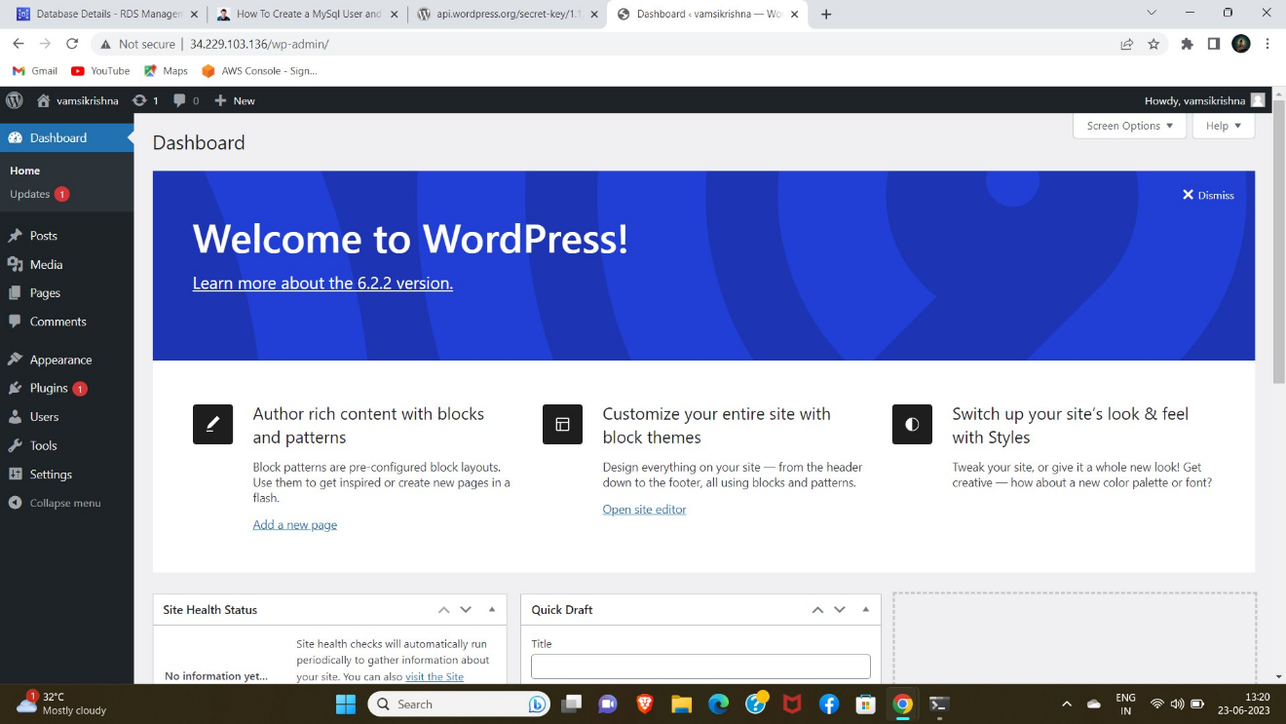

Login and give user name and password & mail.